**IDEA OR APPROACH DETAILS**

**College code:** 7237

**PROBLEM STATEMENT:** An interactive chat or virtual assistant to be developed for the “Department of Justice” website resulting into desired information as per the command. AI chatbots, powered by advanced natural language processing (NLP) and machine learning algorithms, offer a scalable and efficient means to streamline communication, enhance public engagement, and improve internal workflows. This technology can handle a wide range of inquiries, from answering frequently asked questions and providing legal information to assisting in administrative tasks and case management.

**Team Leader**: P. Ashmita

**ABSTRACT**

The Node.js server acts as the brain of the chatbot. It handles, Natural Language Processing, Dialogue Management and API Integration. Express.js simplifies server-side development in Node.js. The React.js frontend creates the visual components of the chatbot, such as the chat window, input field, and buttons. The created chatbot will leverage advanced natural language processing (NLP) techniques to understand user queries, generate relevant responses, and learn from interactions over time. The chatbot will be designed to provide efficient and accurate information to both internal DoJ staff and external users. Key functionalities will includes Legal information retrieval, Case status updates, Form assistance. The chatbot will be trained on a comprehensive dataset of legal documents, case law, and frequently asked questions specific to the DoJ. By continuously learning and adapting, the chatbot will enhance its ability to provide accurate and helpful responses over time.

**TOOLS USED**

* **HTML**
* **CSS**
* **JAVASCRIPT**

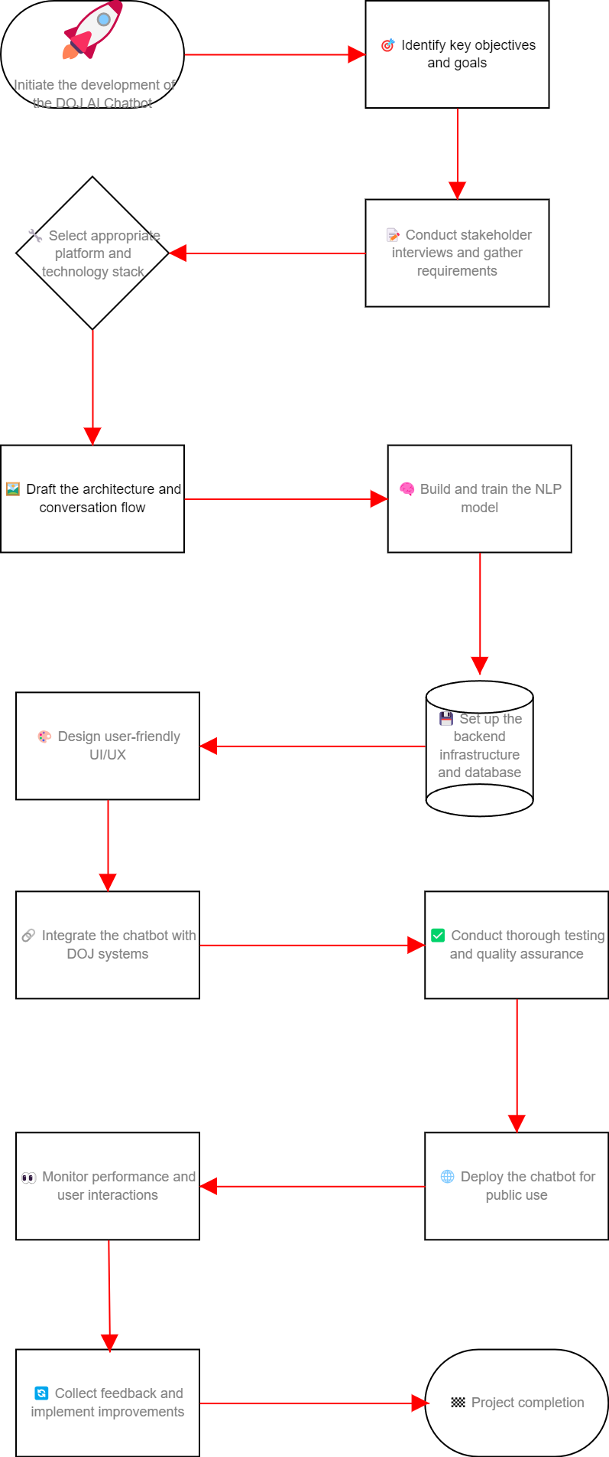 **FLOWCHART:**